Lab task 5

Task 1

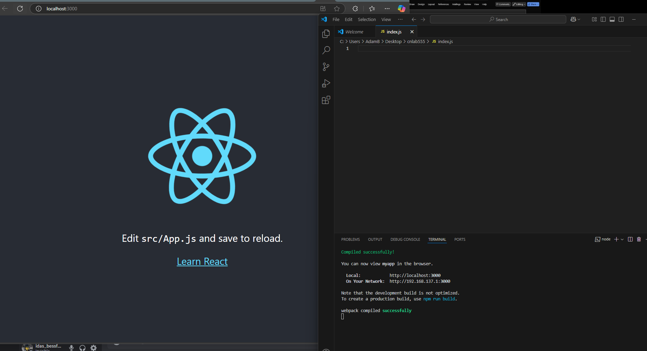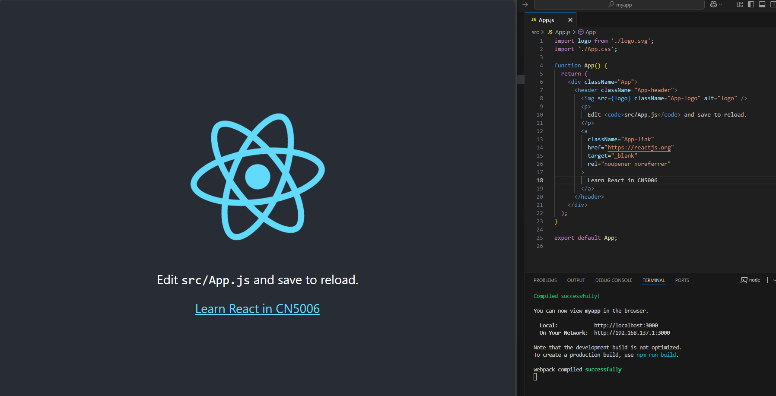

Task 2

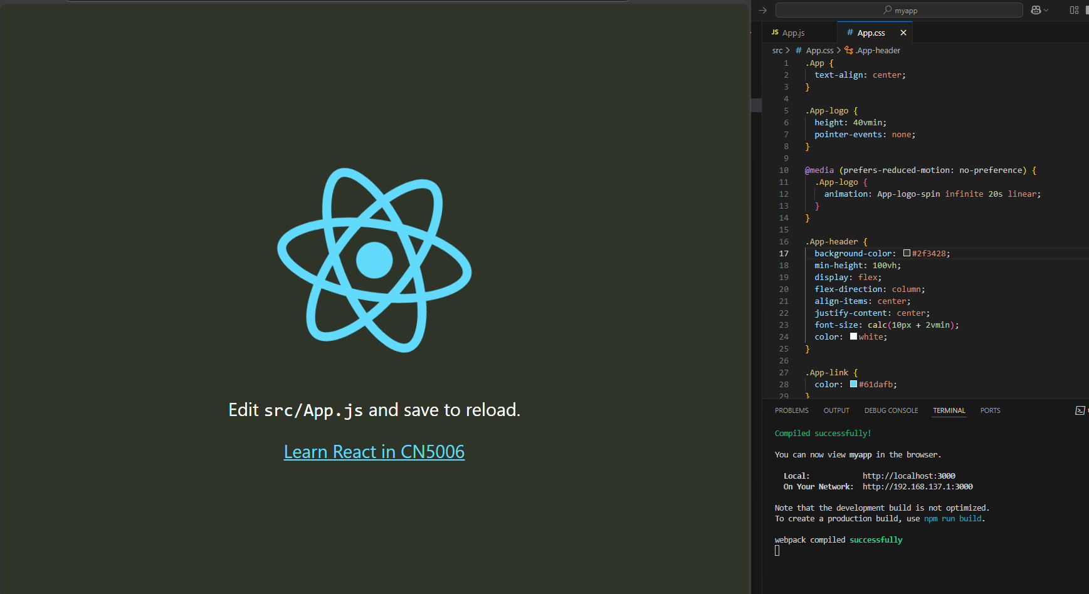

Greeting with html tag:

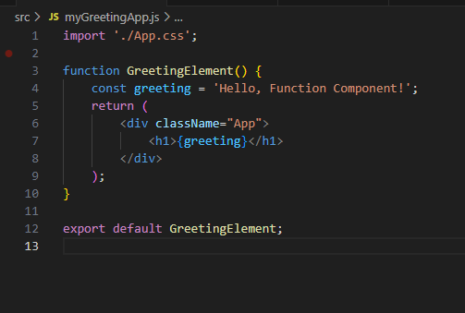

AppbackgroundColor.js file for buttons and html code. App.css for buttons styles and color:

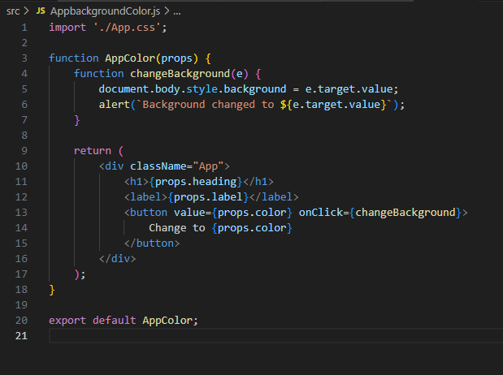

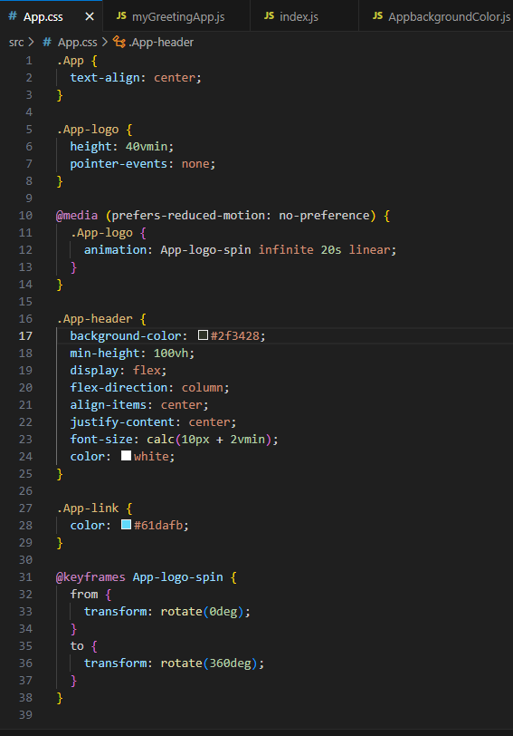

App color code:

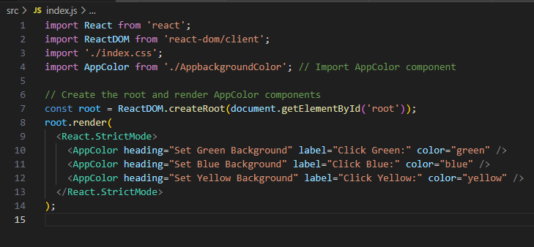

Question 1:

React is a JavaScript library used to build dynamic and interactive user interfaces, primarily for web applications. It allows developers to create reusable components, manage the UI efficiently with a virtual DOM, and handle dynamic data with ease.

Question 2:

A React component is a reusable, self-contained block of code that returns HTML (via JSX). Components can be functional or class-based. To create a functional component without properties:

Question 3:

import React from 'react';  
import ReactDOM from 'react-dom/client';  
import MyReact from './MyReact';  
  
const root = ReactDOM.createRoot(document.getElementById('root'));  
root.render(<MyReact />);

Question 4:

**Component (MyReact.js):**

javascript

function MyReact(props) {  
 return <h1>{props.heading}</h1>;  
}  
export default MyReact;

Rendering:

import React from 'react';

import ReactDOM from 'react-dom/client';

import MyReact from './MyReact';

const root = ReactDOM.createRoot(document.getElementById('root'));

root.render(<MyReact heading="This is my first element" />);

Question 5/6

React component is called Appcolor,three properties are used.

Question 7:

1- Replace question marks with GreetingElementwithProp

